Request for Proposals

[Organization Name]
Design and Installation of a
Rooftop Solar Photovoltaic System

DEADLINE FOR SUBMITTING PROPOSALS:
xx/xx/xx

All proposals must be submitted in person, by mail or by electronic mail to:

[name], Executive Director
[organization]
[organization address]
[email]

Pre-Proposal Site Visit and Questions
A pre-proposal site visit will be held to show potential bidders the proposed installation site at [Organization] and answer any questions or concerns.

Date: xx/xx/xx
Time: 0:00pm
Location: [site address]

- INTRODUCTION
In this section, include background information about the organization (“Organization”), the proposed project and any goals/objectives of the project for the contractor. It also may include information about the funding source and any requirements specific to the funding source. The goals and objectives may be a short narrative, a bulleted list or in a tabular format.
The final paragraph might read:
Organization is soliciting proposals from a qualified contractor to design and install a rooftop solar photovoltaic system at [site address]; train organization staff to adequately perform operation and maintenance basic tasks; and participate in local publicity related to this project’s goals, as requested.
- PRE-PROPOSAL SITE VISIT AND QUESTIONS
A pre-proposal site visit and question forum will be held on [xx/xx/xx from 0:00pm to 0:00pm (PST)]. This will be the contractor’s time to look at the solar installation site and ask any questions about the project.
The pre-proposal meeting will be at the following location:
[site address]

Please direct any questions about this Request for Proposals to the following project contacts:
[Primary contact, organization]
[email, phone]

[Secondary contact, organization]
[email, phone]

- SCOPE OF WORK
The contractor shall complete the following Scope of Work in conformance with all terms and conditions as stated in Section 4.
- Grid-tied Photovoltaic System
  - Objective. The contractor shall obtain all necessary equipment, materials, design, manufacturing, and construction services for the installation of a rooftop grid-tied photovoltaic system at [site address]. The system shall:
    - Produce a minimum of ____ kWh AC per year at the point of interconnection, approximately __ kW DC capacity. Larger capacity systems that produce more than the minimum are an alternative and will be evaluated based on budgetary constraints, but the proposed system shall not produce more than ____ kWh per year.
  - Scope. The contractor shall perform all professional services as necessary to provide Organization with a complete design of the proposed project. The system should be designed and engineered to maximize the solar energy resource, taking into consideration organization’s electrical demand and load patterns, proposed installation site and available solar resource. After approval of a final design by Organization’s primary contact, contractor shall provide all necessary materials, equipment and labor to construct and successfully complete the photovoltaic system installation and interconnection with the electrical grid.
- Train Facilities Staff
  - Objective. Organization has a number of people on staff involved with operations and maintenance of the facility. These staff will be included in the project to understand how the new photovoltaic system may affect other parts of the facility, perform operations and maintenance to ensure consistent peak performance of the system, and be able to troubleshoot and request a callback when necessary.
  - Scope. The contractor shall provide approved training for designated personnel in the operation of the entire photovoltaic system, including operation and maintenance of inverter(s), transfer switches, panel board, disconnects and other features as requested by Organization. The contractor shall also provide to Organization written instructions and procedures for shut-down and start-up activities for all components of the system.
- Publicity
  - Scope. The contractor shall participate in publicity related to this project’s goals, as requested, to promote the benefits of the project in the community and thank the funder, if applicable.
- TERMS AND CONDITIONS OF CONTRACT
The following terms and conditions are designed to state expectations relating to the project and the contractor’s work performed. Should the contractor deviate from these standards and guidelines, all costs and liability associated with the observed deviation will be the sole responsibility of the contractor.
- Contractor Responsibilities. It is the responsibility of the contractor to deliver quality services in compliance with the project requirements. In addition, it is the responsibility of the contractor to:
- Hold the correct permits and licenses necessary to conduct business in the state of state, county and the city where the project is taking place, including but not limited to an Electrical Contractor license classification designated by the state license board, and/or a Solar Contractor license classification designated by the state license board, in good standing.
- Uphold a professional demeanor while on a job site.
- Conduct a pre-installation job walk to verify system design and identify safety issues and/or code violations within the project scope.
- Perform work as specified in Section 3 and in accordance with all project requirements and all applicable laws and codes.
- Dispose of all materials in a safe manner in accordance with all state and federal regulations.
- Work with Organization to ensure the project is completed within the project timeline and budget while minimizing disturbance.

- Interpretation of Scope of Work. The contractor is responsible for reading and fully understanding the scope of work. The design-build approach allows for continual collaboration; however, any proposed changes reducing or adding more than $100 to the original proposal must be approved in writing by the contractor and Organization through the change order process before proceeding.

- Existing Conditions. The contractor is responsible for verifying existing conditions of the installation site as reported in this Request for Proposals before construction begins.
- Installation Schedule. The contractor will complete the installation within the timeline described in Section 7. The installation shall not be done piecemeal. Once the installation has begun, the contractor is required to be on site every day during normal business hours (or at a time pre-arranged with Organization) for the full work period until the installation is complete.
- The contractor shall have all required materials in stock prior to beginning installation.
- The contractor shall give Organization an estimate of the date the installation will be completed and shall inform Organization if the installation appears to be taking longer than the original estimate.
- Corrections as identified during final acceptance or as a result of the quality control process shall be performed within ten (10) business days unless the problem interrupts Organization normal business operations or presents a health and safety threat, in which case the correction shall be made immediately. Exceptions to this rule shall be granted in circumstances beyond the control of the contractor (e.g., unforeseen existing conditions, material backorders, etc.). The contractor shall notify Organization (verbally and in writing) that the correction will or may violate this provision.

- Design. The contractor shall adhere to the following design guidelines:
- Roof loading from the photovoltaic system shall not exceed existing roof framing capacity, as determined by structural loading calculations stamped by a [State]-licensed professional structural engineer.
- System layout shall meet local fire department, code and ordinance requirements for roof access.
- The project shall not interfere with roof drains, water drainage, expansion joints, air intakes, existing electrical and mechanical equipment, and existing antennas.
- The system shall be mounted using the best means practicable, such as direct attachment or a fully ballasted system.
- Mounting system needs to meet applicable local building code requirements with respect to snow, wind and earthquake factors.
- All penetrations and structural connections associated with supports and conduit shall be kept to a minimum and shall be waterproof.
- All roof penetrations shall be designed and constructed in collaboration with a roofing professional or manufacturer responsible for the roof and roofing material warranty for the specific site. All roof installations and weather proofing of penetrations shall not compromise the roof warranty, or if roof has no warranty, accepted best practice. The roof penetration and roof connections shall be warranted for weather tightness for ten (10) years from the installer including parts and labor.

- Materials. The contractor shall procure and ensure proper installation of all materials.
- General
      - Install materials in accordance with manufacturer’s requirements.
      - Provide all labor, materials, tools, equipment and services required to complete the project as specified.
      - Responsible for the cost of all items required for a complete and operating system.
      - Install no materials if:
        - Materials are not compatible with existing conditions.
        - Installation of materials violates equipment warranty.
        - Installation is not to code or industry standard.
- Photovoltaic (PV) Modules
- PV modules shall be a commercial off-the-shelf product, shall be UL listed, and shall be on the [Example: California Senate Bill 1 (SB1) List of Eligible SB1 Guidelines Compliant Photovoltaic Modules] to be eligible for Construction Specifications Institute (CSI), and shall be properly installed according to manufacturer’s instructions, NEC, and as specified herein. (State specific requirements should be added in here).
- PV modules shall have a 25-year limited warranty that modules will generate no less than 80 percent of rated output under STC. PV modules that do not satisfy this warranty condition shall be replaced.
- Inverter(s)
- Inverters shall be commercial off-the-shelf product, listed to UL 1741 and IEEE 1547, and shall be on the [Example: California Senate Bill 1 (SB1) compliant List of Eligible Inverters per SB1 guidelines: http://www.gosolarcalifornia.org/equipment/inverters.php]. (State specific requirements should be added here).
- The inverter shall have at a minimum the following features:
        - UL/ETL listed
        - Peak efficiency of 96 percent or higher
        - Inverter shall have operational indicators of performance and have built-in data acquisition and remote monitoring.
        - The inverter shall be capable of parallel operation with the existing AC power. Each inverter shall automatically synchronize its output waveform with that of the utility upon restoration of utility power.
        - Warning labels shall be posted on the control panels and junction boxes indicating that the circuits are energized by an alternate power source independent of utility-provided power.
        - Operating instructions shall be posted on or near the system, and on file with facilities operation and maintenance documents.
        - Provide detailed lockout /tagout instructions for all equipment.
        - A 10-year manufacturer’s warranty shall be provided.
- Electrical Wiring
- Areas where wiring passes through ceilings, walls or other areas of the building shall be properly restored, booted, sealed and returned to their original condition.
- Thermal insulation in areas where there is wiring shall be replaced to “as found or better condition.” Access doors to these areas shall be properly sealed.
- Structural Components
- All structural components shall be non-corrosive (galvanized steel, stainless steel or aluminum). All hardware shall be stainless steel or aluminum. All components shall be designed to obtain a minimum 40-year design life.
- Code Compliance. Installation and equipment shall comply with applicable building, mechanical, fire, seismic, structural and electrical codes. Defining and determining code violations is not the responsibility of Organization. Only products that are listed, tested, identified or labeled by UL, FM, ETL or another Nationally Recognized Testing Laboratory shall be used as components in the project. Non-listed products are permitted for use as project components only when a comparable usable listed component does not exist. Non-listed products proposed for use as components must be identified as such in all submittals. The publications listed below form a part of this document and are hereby incorporated by reference:
- National Electrical Code (NEC)
- UL 1703 Flat – Plate PV Modules and Panels
- UL 1741 – Standard for Static Inverters and Charge Controllers for Use in Photovoltaic Power Systems
- FM Approved – Fire Protection Tests for Solar Component Products
- IEC 62446 Grid Connected Photovoltaic Systems – Minimum Requirements for System Documentation, Commissioning Tests and Inspections

Other technical codes that shall apply include:

- ASME PTC 50 (solar PV performance)
- ANSI Z21.83 (solar PV performance and safety)
- NFPA 853 (solar PV systems near buildings)
- IEEE 1547 (interconnections)
- ASCE/ SEI-7 – American Society of Civil Engineers – “Minimum Design Loads for Buildings and Other Structures”
- NRCA – National Roofing Contractors Association

- Permits. The contractor shall obtain all required permits and licenses for the project. All fees associated with the permits and licenses are the responsibility of the contractor.

- Safety. The contractor shall observe and comply with all applicable laws, ordinances, codes and regulations of governmental agencies, including federal, state, municipal and local governing bodies having jurisdiction over any or all of the scope of services, including all provisions of the Occupational Safety and Health Act of 1979 as amended, and all other applicable federal, state, municipal and local safety regulations. All services performed by the contractor must be in accordance with these laws, ordinances, codes and regulations. The contractor shall release, defend, indemnify and hold harmless Organization, its officers, agents, volunteers and employees from any and all damages, liability, fines, penalties and consequences from any noncompliance or violation of any laws, ordinances, codes or regulations. Additionally, the following requirements must be met:
- All roof access points shall be securely locked at the end of each day.
- If a release of hazardous materials or hazardous waste that cannot be controlled occurs in connection with the performance of this contract, the contractor shall immediately notify the appropriate public safety service (police, fire rescue, or emergency medical services), Organization Executive Director, and project designees. The contractor shall not store hazardous materials or hazardous waste without proper permits.

- Damage and Disposal. The contractor shall proceed with work in a manner that does not damage existing materials/infrastructure unless otherwise directed by Organization:
- The contractor shall document pre-existing damage to the materials/infrastructure and report any such damage to Organization.
- The contractor shall repair at its own expense damage to buildings and equipment caused by work done for this project.
- The contractor shall remove all materials, equipment and debris immediately upon completion of the project or at the end of each workday (unless Organization agrees to provide storage space).
- The contractor shall keep access to all areas of the building clear.
- The contractor shall not use on-premise refuse containers for disposal of any material whatsoever without prior approval of Organization.
- The contractor shall protect people and property from damage and debris at all times during the construction process.

- Hazardous Material Clean-Up. All surfaces and articles contaminated by hazardous materials in the course of this work shall be cleaned in accordance with all applicable laws, codes, and ordinances and be transported safely to the appropriate destruction/servicing facilities. The contractor shall comply with the regulations for the management of hazardous waste as specified in the [applicable state code].

- Communication. The contractor shall respond to information requests within two (2) business days. Response form will be determined by the request. The response may be in the following forms but not be limited to: E-mail, hardcopy, fax, voice.
- Change Orders and Scope of Work Modification. The contract may be increased or decreased after the proposal is accepted. Under no circumstances shall the contractor deviate from the work defined in the scope of work without advance written approval from Organization.

- Inspection. Upon completion of the installation, Organization will perform an inspection of the physical installation, as well as all paperwork submitted by the contractor. Once on-site, the representative or assignee shall ensure that all contractually agreed upon work was completed and confirm:
- The make and model of equipment installed.
- Quality workmanship of installation.
- A brief review of findings as compared to the initial description of the site, scope of work, any change order(s) and final invoice.
During the post-install site inspection, the inspecting person will record any corrections to the installation that need to be made by the contractor. If, during the post-installation inspection, the program finds discrepancies between the work performed and the scope of work, installation standards and/or equipment specifications, the contractor will be responsible, at the contractor's expense, for bringing the installation into conformance before the contractor is be paid. Installation corrections as noted during final acceptance or the post-installation inspection shall be performed within ten (10) business days. If the contractor cannot undertake corrective actions within ten (10) business days, the contractor shall deliver, in writing, reasons for the delay.
- Interconnection Agreement. The contractor shall coordinate with [local utility] to ensure that the project satisfies all [local utility] criteria for interconnection of the project to the [local utility] electric distribution system. This includes:
- Participating in any needed interaction between [local utility and organization].
- Preparing required submissions for obtaining Net Energy Metering and interconnection from [local utility].
- The contractor shall manage interconnection and startup of project in coordination with Organization and [local utility]. The contractor shall, at its own expense, pay any interconnection, processing and other fees and expenses as may be required by [local utility] for interconnection and operation of the project.

- Commissioning. The contractor shall perform commissioning of the entire PV system. This data shall be used to confirm proper performance of the PV system. Performance tests shall be conducted at the final commissioning/acceptance testing, and one year after the acceptance date. If performance is less than 90 percent at the one-year performance tests using current industry standards, contractor shall promptly troubleshoot and correct any malfunction or issues as necessary to return project to 90 percent measured performance or better.
- As-Built Drawings and Specifications. The contractor shall provide “as-built drawings” and documents based upon actual site installation. Should Organization determine that variations exist between finished construction and the as-built drawings, the contractor shall correct drawings to the satisfaction of Organization.
- Warranties and Guarantees. Submit specific warranties and guarantees, final certifications and similar documents to Organization upon substantial completion and prior to final payment. Include copies with operations and maintenance manual. All warranties shall be signed by a principal of the contractor’s firm and sealed if a corporation.

- Final Acceptance. A project will not be considered complete until all project steps are completed, including quality control inspection, training and all project deliverables.

- Payment. The invoice shall reflect the dollar amount of the proposal plus or minus any executed change order amounts. Executed change orders will supersede primary scope of work at all times. Additional change orders may expand on or supersede previous change orders. These dollar amounts are payable to the contractor upon submission of the project deliverables and the final quality control inspection. Invoices shall be submitted to Organization (Attn: [Primary Contact]) within two weeks of final project acceptance.
- ELIGIBILITY
Contractor eligibility requirements are discussed below.
- Compliance with Applicable Laws. The contractor shall comply with any and all applicable federal, state and local laws affecting the services covered by this Agreement.
- State Licensing Requirements. The selected contractor must maintain appropriate licenses at all times during the installations performed for this project. (Additional language specific to the state may be added. For example, in California the following language can be included: In addition to maintaining said license, firms must be in good standing with the California State Licensing Board (CSLB). C-10-Electrical Contractor or C-46-Solar Contractor license classifications are eligible for this project.)
- Commercial General Liability Insurance. The limit shall not be less than $1,000,000 each occurrence or $2,000,000 in aggregate for bodily injury, property damage and personal injury. The selected contractor must forward current insurance certificate to Organization. Certificate must:
    - Have an “Additional Insured” endorsement that adds Organization and its affiliates, subsidiaries and directors, officers, managers, agents and employees with respect to liability arising out of or connected with the work performed for the project (ISO Form CG2010 or equivalent is preferred). In the event the commercial general liability policy includes a “blanket endorsement by contract,” the following language must be added to meet the additional insured requirement: “Organization, its affiliates, subsidiaries, and directors, officers, managers, agents and employees with respect to liability arising out of the work performed by or for Organization are additional insured under a blanket endorsement.”
    - Be endorsed to specify that the contractor’s insurance is primary and that any insurance or self-insurance maintained by Organization shall not contribute with it.
    - All insurance policies shall provide that the insurance carrier shall not cancel, terminate or otherwise modify the terms and conditions of said policies except upon thirty (30) days written notice to Organization. If the commercial general liability insurance referred to above is written on a claims-made form, then following termination of this program, coverage shall survive for a period of not less than five (5) years. Coverage shall also provide for a retroactive date of placement coinciding with the effective date of this contract.

- Business Auto Insurance. The limit shall not be less than $1,000,000.00 for each accident for both bodily injury and property damage.

- Worker’s Compensation Insurance. The contractor must meet the following provisions:
    - Provide that the insurance carrier not cancel, terminate or otherwise modify the terms and conditions of said insurance except when thirty (30) days written notice is delivered. Delivery must include [Organization, Primary Contact].
    - Provide for a waiver of any right of subrogation against Organization to the extent permitted by law.

6. INSTRUCTIONS FOR SUBMITTING A PROPOSAL
Please submit the following information:
- Cover page. Including:
- Title of Request for Proposal
- Name, address, phone number and license numbers of firm, including contact names, titles and email addresses.
- Solar Design and Build Plan. Please provide an overview of the proposed design of the photovoltaic system, including:
- Key Equipment Information
      - Description/size
      - Performance
      - Any additional recommended controls, monitors or instrumentation not otherwise specified associated with the proposed equipment
- Installation and Interconnection Information
      - Layout of installation
      - PV array orientation (degrees)
      - PV module tilt (degrees)
      - Integration of the system with other power sources (one-line electrical diagram showing inverters, meters and interconnection locations)
      - Subcontractors and associated subcontracted scope of work
- Predicted system energy production (kWh)

- Quality Control. Please provide a statement of how your firm will be prepared to work within the project timeline and in a timely manner, ensure conformance with quality control standards, and respond to quality control issues during and after completion of the project.

- Qualifications. Please provide an outline of your firm’s qualifications to perform the Scope of Work. Please specify qualifications related to the following areas:
- Commercial rooftop grid-tied solar PV design and installation
- Experience training others on the operations and maintenance of solar PV systems

- Price. Please indicate the total price for which your firm can provide all services described in Section 3, Scope of Work. Please note that discounted pricing or donations of labor or materials would be appreciated, and could potentially be eligible for a tax deduction.
- Time. Please present a schedule from notice to proceed through final completion.

- Exhibits. Please attach any supporting documents that will be helpful in determining the qualifications of your firm to perform the work.

7. SCHEDULE
The following is a schedule of significant events and deadlines:

Pre-proposal site walk: xx/xx/xx, 0:00pm
Proposals due: xx/xx/xx, 0:00pm
Anticipated award date: xx/xx/xx
Installation: xx/xx/xx
Project acceptance/Ribbon-cutting: xx/xx/xx

APPENDIX A: SITE DESCRIPTION
  - Aerial view of [proposed location]
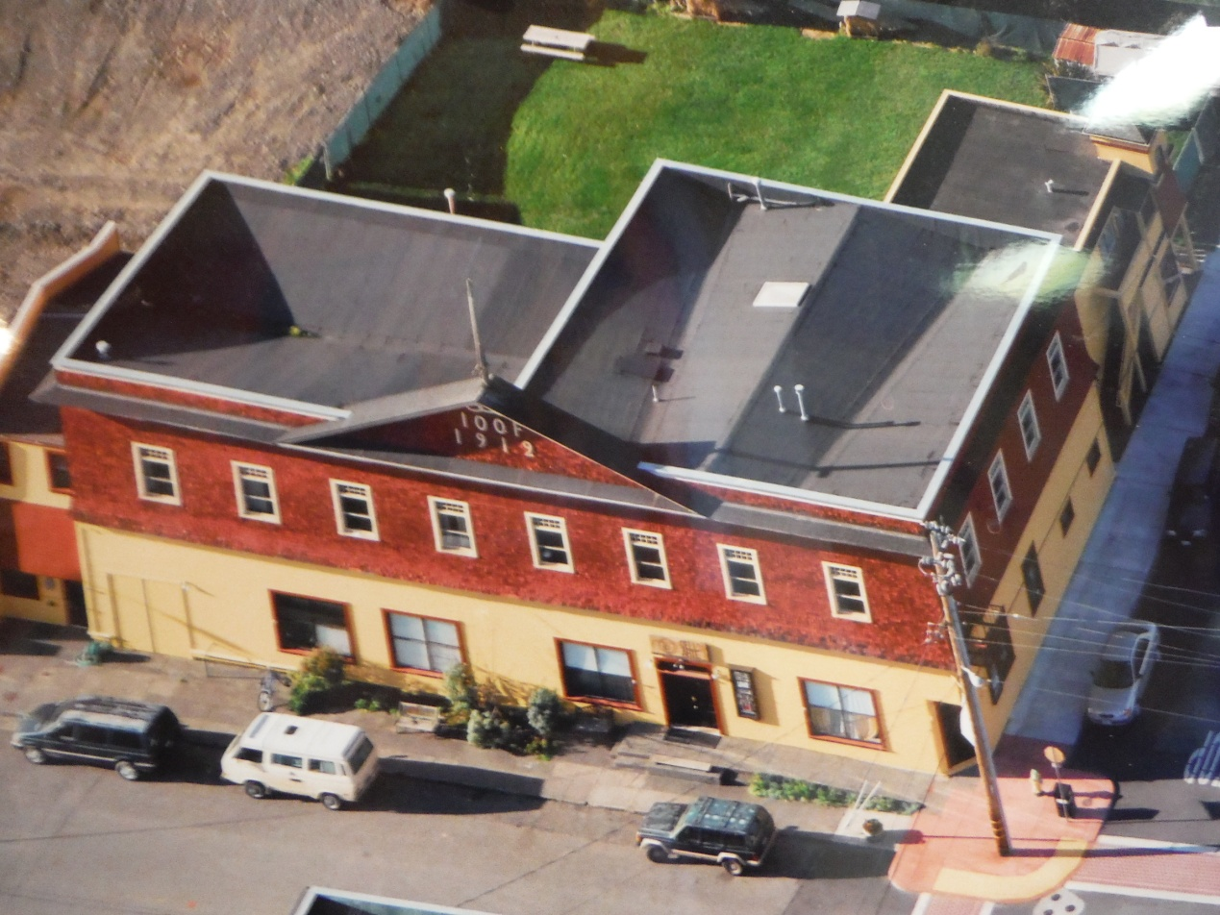
  - [Proposed installation site]
